**PHP Assignment**

**MODULE – 2 HTML, CSS, SQL**

**Exercise 1: Try To Create User Details Form.**

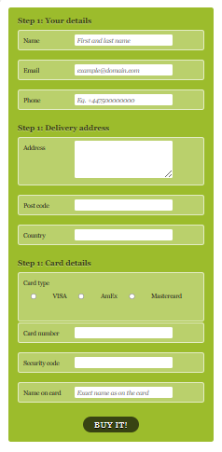

<!DOCTYPE html>

<html>

<head>

<meta charset="utf-8" />

<title>User Details Form </title>

<style>

html, body, h1, form, fieldset, legend, ol, li {

    margin: 0;

    padding: 0;

}

body {

    background: #ffffff;

    color: #111111;

    font-family: Georgia, "Times New Roman", Times, serif;

    padding: 20px;

}

form#payment {

    background: #9cbc2c;

    -moz-border-radius: 5px;

    -webkit-border-radius: 5px;

    border-radius: 5px;

    padding: 20px;

    width: 400px;

}

form#payment fieldset {

    border: none;

    margin-bottom: 10px;

}

form#payment fieldset:last-of-type {

    margin-bottom: 0;

}

form#payment legend {

    color: #384313;

    font-size: 16px;

    font-weight: bold;

    padding-bottom: 10px;

    text-shadow: 0 1px 1px #c0d576;

}

form#payment > fieldset > legend:before {

    content: "Step " counter(fieldsets) ": ";

    counter-increment: fieldsets;

}

form#payment fieldset fieldset legend {

    color: #111111;

    font-size: 13px;

    font-weight: normal;

    padding-bottom: 0;

}

form#payment ol li {

    background: #b9cf6a;

    background: rgba(255,255,255,.3);

    border-color: #e3ebc3;

    border-color: rgba(255,255,255,.6);

    border-style: solid;

    border-width: 2px;

    -moz-border-radius: 5px;

    -webkit-border-radius: 5px;

    border-radius: 5px;

    line-height: 30px;

    list-style: none;

    padding: 5px 10px;

    margin-bottom: 2px;

}

form#payment ol ol li {

    background: none;

    border: none;

    float: left;

}

form#payment label {

    float: left;

    font-size: 13px;

    width: 110px;

}

form#payment fieldset fieldset label {

    background:none no-repeat left 50%;

    line-height: 20px;

    padding: 0 0 0 30px;

    width: auto;

}

form#payment label[for=visa] {

    background-image: url(visa.png);

}

form#payment label[for=amex] {

    background-image: url(comparacion_amex.gif);

}

form#payment label[for=mastercard] {

    background-image: url(mastercard-logo.png);

}

form#payment fieldset fieldset label:hover {

    cursor: pointer;

}

form#payment input:not([type=radio]),

form#payment textarea {

    background: #ffffff;

    border: none;

    -moz-border-radius: 3px;

    -webkit-border-radius: 3px;

    -khtml-border-radius: 3px;

    border-radius: 3px;

    font: italic 13px Georgia, "Times New Roman", Times, serif;

    outline: none;

    padding: 5px;

    width: 200px;

}

form#payment input:not([type=submit]):focus,

form#payment textarea:focus {

    background: #eaeaea;

}

form#payment input[type=radio] {

    float: left;

    margin-right: 5px;

}

form#payment button {

    background: #384313;

    border: none;

    -moz-border-radius: 20px;

    -webkit-border-radius: 20px;

    -khtml-border-radius: 20px;

    border-radius: 20px;

    color: #ffffff;

    display: block;

    font: 18px Georgia, "Times New Roman", Times, serif;

    letter-spacing: 1px;

    margin: auto;

    padding: 7px 25px;

    text-shadow: 0 1px 1px #000000;

    text-transform: uppercase;

}

form#payment button:hover {

    background: #1e2506;

    cursor: pointer;

}

</style>

</head>

<body background-color="green">

<form id="payment">

<fieldset>

<legend>Your Details</legend>

<ol>

<li>

<label>Name</label>

<input id="name" type="text" name="name" placeholder="First Name And Last Name " required>

</li><br>

<li>

<label>Email</label>

<input id="email" type="email" name="email" placeholder="Enetr Email" required>

</li><br>

<li>

<label>Phone</label>

<input id="phone" type="number" name="phone" placeholder="Enter Mobile Number " required>

</li><br>

</ol>

</fieldset>

<fieldset>

<legend>Delivery Address</legend>

<ol>

<li>

<label>Address</label>

<textarea id="address" name="address" required></textarea>

</li><br>

<li>

<label>Post Code</label>

<input id="postcode" type="text" name="postcode" placeholder="Enter Post Code" required>

</li><br>

<li>

<label>Country</label>

<input id="country" type="text" name="country" placeholder="Enter Country" required>

</li><br>

</ol>

</fieldset>

<fieldset>

<legend>Card Details</legend>

<ol>

<li>

<fieldset>

<legend>Card Type</legend>

<ol>

<li>

<label>VISA</label>

<input id="visa" type="radio" name="cardtype">

</li>

<li>

<label>AmEx</label>

<input id="amex" type="radio" name="cardtype">

</li>

<li>

<label>Master Card</label>

<input id="mastercard" type="radio" name="cardtype">

</li>

</ol>

</fieldset> <br>

</li>

<li>

<label>Card Number</label>

<input id="cardnumber" type="number" name="cardnumber" >

</li><br>

<li>

<label>Security Code</label>

<input id="secure" type="number" name="secure" >

</li><br>

<li>

<label>Name On Card</label>

<input id="namecard" type="text" name="namecard" >

</li><br>

</ol>

</fieldset>

<fieldset align="center">

<button type="submit">Buy it!</button>

</fieldset>

</form>

</body>

</html>

**BOOTSRAP**

**Exercise 1: Create manage Profile:**

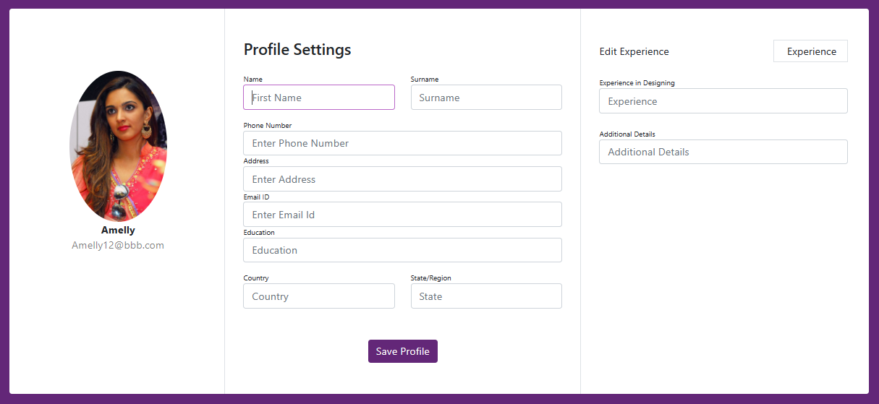

<<!DOCTYPE html>

<html>

<head>

<meta charset="utf-8" />

<meta http-equiv="X-UA-Compatible" content="IE=edge">

<title>Manage Profile </title>

<meta name="viewport" content="width=device-width, initial-scale=1">

<link rel="stylesheet" type="text/css" media="screen" href="https://cdn.jsdelivr.net/npm/bootstrap@5.0.0-alpha1/dist/css/bootstrap.min.css" />

<script src="https://cdn.jsdelivr.net/npm/bootstrap@5.0.0-alpha1/dist/js/bootstrap.bundle.min.js"></script>

<style>

body {

background: rgb(99, 39, 120)

}

.form-control:focus {

box-shadow: none;

border-color: #BA68C8

}

.profile-button {

background: rgb(99, 39, 120);

box-shadow: none;

border: none

}

.profile-button:hover {

background: #682773

}

.profile-button:focus {

background: #682773;

box-shadow: none

}

.profile-button:active {

background: #682773;

box-shadow: none

}

.back:hover {

color: #682773;

cursor: pointer

}

.labels {

font-size: 11px

}

.add-experience:hover {

background: #BA68C8;

color: #fff;

cursor: pointer;

border: solid 1px #BA68C8

}

</style>

</head>

<body>

<div class="container rounded bg-white mt-5 mb-5">

<div class="row">

<div class="col-md-3 border-right">

<div class="d-flex flex-column align-items-center text-center p-3 py-5"><img class="rounded-circle mt-5" width="150px" src="https://i.pinimg.com/564x/31/45/fa/3145fad028d000fc23e1b13a7181e2a3.jpg"><span class="font-weight-bold">Amelly</span><span class="text-black-50">Amelly12@bbb.com</span><span> </span></div>

</div>

<div class="col-md-5 border-right">

<div class="p-3 py-5">

<div class="d-flex justify-content-between align-items-center mb-3">

<h4 class="text-right">Profile Settings</h4>

</div>

<div class="row mt-2">

<div class="col-md-6"><label class="labels">Name</label><input type="text" class="form-control" placeholder="First Name" value=""></div>

<div class="col-md-6"><label class="labels">Surname</label><input type="text" class="form-control" value="" placeholder="Surname"></div>

</div>

<div class="row mt-3">

<div class="col-md-12"><label class="labels">Phone Number</label><input type="text" class="form-control" placeholder="Enter Phone Number" value=""></div>

<div class="col-md-12"><label class="labels">Address </label><input type="text" class="form-control" placeholder="Enter Address " value=""></div>

<div class="col-md-12"><label class="labels">Email ID</label><input type="text" class="form-control" placeholder="Enter Email Id" value=""></div>

<div class="col-md-12"><label class="labels">Education</label><input type="text" class="form-control" placeholder="Education" value=""></div>

</div>

<div class="row mt-3">

<div class="col-md-6"><label class="labels">Country</label><input type="text" class="form-control" placeholder="Country" value=""></div>

<div class="col-md-6"><label class="labels">State/Region</label><input type="text" class="form-control" value="" placeholder="State"></div>

</div>

<div class="mt-5 text-center"><button class="btn btn-primary profile-button" type="button">Save Profile</button></div>

</div>

</div>

<div class="col-md-4">

<div class="p-3 py-5">

<div class="d-flex justify-content-between align-items-center experience"><span>Edit Experience</span><span class="border px-3 p-1 add-experience"><i class="fa fa-plus"></i>&nbsp;Experience</span></div><br>

<div class="col-md-12"><label class="labels">Experience in Designing</label><input type="text" class="form-control" placeholder="Experience" value=""></div> <br>

<div class="col-md-12"><label class="labels">Additional Details</label><input type="text" class="form-control" placeholder="Additional Details" value=""></div>

</div>

</div>

</div>

</div>

</div>

</div>

</body>

</html>

**Exercise2 : Create Product Listing Page:**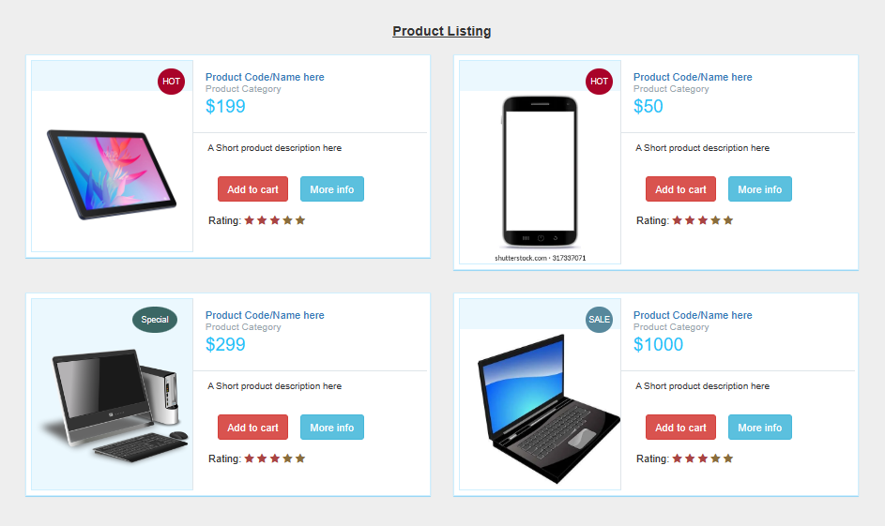

<!DOCTYPE html>

<html>

<head>

<title>Product Listing</title>

<link rel="stylesheet" href="https://maxcdn.bootstrapcdn.com/bootstrap/3.3.5/css/bootstrap.min.css" integrity="sha512-dTfge/zgoMYpP7QbHy4gWMEGsbsdZeCXz7irItjcC3sPUFtf0kuFbDz/ixG7ArTxmDjLXDmezHubeNikyKGVyQ==" crossorigin="anonymous">

<link href="https://maxcdn.bootstrapcdn.com/font-awesome/4.3.0/css/font-awesome.min.css" rel="stylesheet">

<style>

body{

margin-top:20px;

background:#eee;

}

.prod-info-main {

border: 1px solid #CEEFFF;

margin-bottom: 20px;

margin-top: 10px;

background: #fff;

padding: 6px;

-webkit-box-shadow: 0 1px 4px 0 rgba(17, 24, 27, 0.5);

box-shadow: 0 1px 1px 0 rgba(21,180,255,0.5);

}

.prod-info-main .product-image {

background-color: #EBF8FE;

display: block;

min-height: 238px;

overflow: hidden;

position: relative;

border: 1px solid #CEEFFF;

padding-top: 40px;

}

.prod-info-main .product-deatil {

border-bottom: 1px solid #dfe5e9;

padding-bottom: 17px;

padding-left: 16px;

padding-top: 16px;

position: relative;

background: #fff

}

.product-content .product-deatil h5 a {

color: #2f383d;

font-size: 15px;

line-height: 19px;

text-decoration: none;

padding-left: 0;

margin-left: 0

}

.prod-info-main .product-deatil h5 a span {

color: #9aa7af;

display: block;

font-size: 13px

}

.prod-info-main .product-deatil span.tag1 {

border-radius: 50%;

color: #fff;

font-size: 15px;

height: 50px;

padding: 13px 0;

position: absolute;

right: 10px;

text-align: center;

top: 10px;

width: 50px

}

.prod-info-main .product-deatil span.sale {

background-color: #21c2f8

}

.prod-info-main .product-deatil span.discount {

background-color: #71e134

}

.prod-info-main .product-deatil span.hot {

background-color: #fa9442

}

.prod-info-main .description {

font-size: 12.5px;

line-height: 20px;

padding: 10px 14px 16px 19px;

background: #fff

}

.prod-info-main .product-info {

padding: 11px 19px 10px 20px

}

.prod-info-main .product-info a.add-to-cart {

color: #2f383d;

font-size: 13px;

padding-left: 16px

}

.prod-info-main name.a {

padding: 5px 10px;

margin-left: 16px

}

.product-info.smart-form .btn {

padding: 6px 12px;

margin-left: 12px;

margin-top: -10px

}

.load-more-btn {

background-color: #21c2f8;

border-bottom: 2px solid #037ca5;

border-radius: 2px;

border-top: 2px solid #0cf;

margin-top: 20px;

padding: 9px 0;

width: 100%

}

.product-block .product-deatil p.price-container span,

.prod-info-main .product-deatil p.price-container span,

.shipping table tbody tr td p.price-container span,

.shopping-items table tbody tr td p.price-container span {

color: #21c2f8;

font-family: Lato, sans-serif;

font-size: 24px;

line-height: 20px

}

.product-info.smart-form .rating label {

margin-top:15px;

}

.prod-wrap .product-image span.tag2 {

position: absolute;

top: 10px;

right: 10px;

width: 36px;

height: 36px;

border-radius: 50%;

padding: 10px 0;

color: #fff;

font-size: 11px;

text-align: center

}

.prod-wrap .product-image span.tag3 {

position: absolute;

top: 10px;

right: 20px;

width: 60px;

height: 36px;

border-radius: 50%;

padding: 10px 0;

color: #fff;

font-size: 11px;

text-align: center

}

.prod-wrap .product-image span.sale {

background-color: #57889c;

}

.prod-wrap .product-image span.hot {

background-color: #a90329;

}

.prod-wrap .product-image span.special {

background-color: #3B6764;

}

.shop-btn {

position: relative

}

.shop-btn>span {

background: #a90329;

display: inline-block;

font-size: 10px;

box-shadow: inset 1px 1px 0 rgba(0, 0, 0, .1), inset 0 -1px 0 rgba(0, 0, 0, .07);

font-weight: 700;

border-radius: 50%;

padding: 2px 4px 3px!important;

text-align: center;

line-height: normal;

width: 19px;

top: -7px;

left: -7px

}

.product-deatil hr {

padding: 0 0 5px!important

}

.product-deatil .glyphicon {

color: #3276b1

}

.product-deatil .product-image {

border-right: 0px solid #fff !important

}

.product-deatil .name {

margin-top: 0;

margin-bottom: 0

}

.product-deatil .name small {

display: block

}

.product-deatil .name a {

margin-left: 0

}

.product-deatil .price-container {

font-size: 24px;

margin: 0;

font-weight: 300;

}

.product-deatil .price-container small {

font-size: 12px;

}

.product-deatil .fa-2x {

font-size: 16px!important

}

.product-deatil .fa-2x>h5 {

font-size: 12px;

margin: 0

}

.product-deatil .fa-2x+a,

.product-deatil .fa-2x+a+a {

font-size: 13px

}

.product-deatil .certified {

margin-top: 10px

}

.product-deatil .certified ul {

padding-left: 0

}

.product-deatil .certified ul li:not(first-child) {

margin-left: -3px

}

.product-deatil .certified ul li {

display: inline-block;

background-color: #f9f9f9;

padding: 13px 19px

}

.product-deatil .certified ul li:first-child {

border-right: none

}

.product-deatil .certified ul li a {

text-align: left;

font-size: 12px;

color: #6d7a83;

line-height: 16px;

text-decoration: none

}

.product-deatil .certified ul li a span {

display: block;

color: #21c2f8;

font-size: 13px;

font-weight: 700;

text-align: center

}

.product-deatil .message-text {

width: calc(100% - 70px)

}

@media only screen and (min-width:1024px) {

.prod-info-main div[class*=col-md-4] {

padding-right: 0

}

.prod-info-main div[class*=col-md-8] {

padding: 0 13px 0 0

}

.prod-wrap div[class*=col-md-5] {

padding-right: 0

}

.prod-wrap div[class*=col-md-7] {

padding: 0 13px 0 0

}

.prod-info-main .product-image {

border-right: 1px solid #dfe5e9

}

.prod-info-main .product-info {

position: relative

}

}

</style>

</head>

<body>

<hr> <center><h4><u><b>Product Listing </h4></b></u></h4></center>

<div class="container">

<div class="col-xs-12 col-md-6">

    <!-- First product box start here-->

    <div class="prod-info-main prod-wrap clearfix">

        <div class="row">

                <div class="col-md-5 col-sm-12 col-xs-12">

                    <div class="product-image">

                        <img src="https://consumer.huawei.com/content/dam/huawei-cbg-site/south-pacific/ph/mkt/plp/tablets-new/view-all/all-matepad-t-10.jpg" class="img-responsive">

                        <span class="tag2 hot">

                            HOT

                        </span>

                    </div>

                </div>

                <div class="col-md-7 col-sm-12 col-xs-12">

                <div class="product-deatil">

                        <h5 class="name">

                            <a href="#">

                                Product Code/Name here

                            </a>

                            <a href="#">

                                <span>Product Category</span>

                            </a>

                        </h5>

                        <p class="price-container">

                            <span>$199</span>

                        </p>

                        <span class="tag1"></span>

                </div>

                <div class="description">

                    <p>A Short product description here </p>

                </div>

                <div class="product-info smart-form">

                    <div class="row">

                        <div class="col-md-12">

                            <a href="javascript:void(0);" class="btn btn-danger">Add to cart</a>

<a href="javascript:void(0);" class="btn btn-info">More info</a>

                        </div>

                        <div class="col-md-12">

                            <div class="rating">Rating:

                                <label for="stars-rating-5"><i class="fa fa-star text-danger"></i></label>

                                <label for="stars-rating-4"><i class="fa fa-star text-danger"></i></label>

                                <label for="stars-rating-3"><i class="fa fa-star text-danger"></i></label>

                                <label for="stars-rating-2"><i class="fa fa-star text-warning"></i></label>

                                <label for="stars-rating-1"><i class="fa fa-star text-warning"></i></label>

                            </div>

                        </div>

                    </div>

                </div>

            </div>

        </div>

    </div>

    <!-- end product -->

</div>

<div class="col-xs-12 col-md-6">

    <!-- Second product box start here-->

    <div class="prod-info-main prod-wrap clearfix">

        <div class="row">

                <div class="col-md-5 col-sm-12 col-xs-12">

                    <div class="product-image">

                        <img src="https://www.shutterstock.com/image-vector/mobile-phone-vector-illustration-260nw-317337071.jpg" alt="194x228" class="img-responsive">

                        <span class="tag2 hot">

                            HOT

                        </span>

                    </div>

                </div>

                <div class="col-md-7 col-sm-12 col-xs-12">

                <div class="product-deatil">

                        <h5 class="name">

                            <a href="#">

                                Product Code/Name here <span>Product Category</span>

                            </a>

                        </h5>

                        <p class="price-container">

                            <span>$50</span>

                        </p>

                        <span class="tag1"></span>

                </div>

                <div class="description">

                    <p>A Short product description here </p>

                </div>

                <div class="product-info smart-form">

                    <div class="row">

                        <div class="col-md-12">

                            <a href="javascript:void(0);" class="btn btn-danger">Add to cart</a>

<a href="javascript:void(0);" class="btn btn-info">More info</a>

                        </div>

                        <div class="col-md-12">

                            <div class="rating">Rating:

                                <label for="stars-rating-5"><i class="fa fa-star text-danger"></i></label>

                                <label for="stars-rating-4"><i class="fa fa-star text-danger"></i></label>

                                <label for="stars-rating-3"><i class="fa fa-star text-danger"></i></label>

                                <label for="stars-rating-2"><i class="fa fa-star text-warning"></i></label>

                                <label for="stars-rating-1"><i class="fa fa-star text-warning"></i></label>

                            </div>

                        </div>

                    </div>

                </div>

            </div>

        </div>

    </div>

    <!-- end product -->

</div>

<div class="col-xs-12 col-md-6">

<!--third product box start here-->

    <div class="prod-info-main prod-wrap clearfix">

        <div class="row">

                <div class="col-md-5 col-sm-12 col-xs-12">

                    <div class="product-image">

                        <img src="https://freesvg.org/img/generic-office-desktop.png" alt="194x228" class="img-responsive">

                        <span class="tag3 special">

                            Special

                        </span>

                    </div>

                </div>

                <div class="col-md-7 col-sm-12 col-xs-12">

                <div class="product-deatil">

                        <h5 class="name">

                            <a href="#">

                                Product Code/Name here <span>Product Category</span>

                            </a>

                        </h5>

                        <p class="price-container">

                            <span>$299</span>

                        </p>

                        <span class="tag1"></span>

                </div>

                <div class="description">

                    <p>A Short product description here </p>

                </div>

                <div class="product-info smart-form">

                    <div class="row">

                        <div class="col-md-12">

                            <a href="javascript:void(0);" class="btn btn-danger">Add to cart</a>

<a href="javascript:void(0);" class="btn btn-info">More info</a>

                        </div>

                        <div class="col-md-12">

                            <div class="rating">Rating:

                                <label for="stars-rating-5"><i class="fa fa-star text-danger"></i></label>

                                <label for="stars-rating-4"><i class="fa fa-star text-danger"></i></label>

                                <label for="stars-rating-3"><i class="fa fa-star text-danger"></i></label>

                                <label for="stars-rating-2"><i class="fa fa-star text-warning"></i></label>

                                <label for="stars-rating-1"><i class="fa fa-star text-warning"></i></label>

                            </div>

                        </div>

                    </div>

                </div>

            </div>

        </div>

    </div>

    <!-- end product -->

</div>

<div class="col-xs-12 col-md-6">

    <!-- Fourth product box start here-->

    <div class="prod-info-main prod-wrap clearfix">

        <div class="row">

                <div class="col-md-5 col-sm-12 col-xs-12">

                    <div class="product-image">

                        <img src="https://5.imimg.com/data5/SELLER/Default/2022/9/JG/LP/AA/52146474/laptop-500x500.jpg" alt="194x228" class="img-responsive">

                        <span class="tag2 sale">

                            SALE

                        </span>

                    </div>

                </div>

                <div class="col-md-7 col-sm-12 col-xs-12">

                <div class="product-deatil">

                        <h5 class="name">

                            <a href="#">

                                Product Code/Name here <span>Product Category</span>

                            </a>

                        </h5>

                        <p class="price-container">

                            <span>$1000</span>

                        </p>

                        <span class="tag1"></span>

                </div>

                <div class="description">

                    <p>A Short product description here </p>

                </div>

                <div class="product-info smart-form">

                    <div class="row">

                        <div class="col-md-12">

                            <a href="javascript:void(0);" class="btn btn-danger">Add to cart</a>

<a href="javascript:void(0);" class="btn btn-info">More info</a>

                        </div>

                        <div class="col-md-12">

                            <div class="rating">Rating:

                                <label for="stars-rating-5"><i class="fa fa-star text-danger"></i></label>

                                <label for="stars-rating-4"><i class="fa fa-star text-danger"></i></label>

                                <label for="stars-rating-3"><i class="fa fa-star text-danger"></i></label>

                                <label for="stars-rating-2"><i class="fa fa-star text-warning"></i></label>

                                <label for="stars-rating-1"><i class="fa fa-star text-warning"></i></label>

                            </div>

                        </div>

                    </div>

                </div>

            </div>

        </div>

    </div>

    <!-- end product -->

</div>

</div>

</body>

</html>

**Topic – SQL Task-1**

**TABLE:- employee**

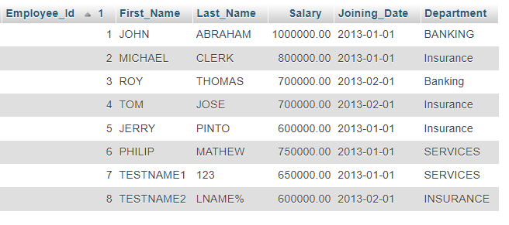

**TABLE :- Incentives**

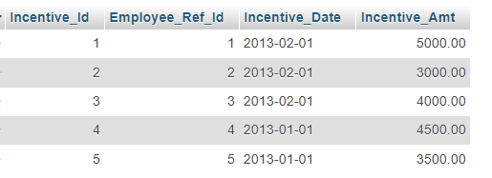

a) Get First_Name from employee table using alias name “Employee Name”.

=> [SELECT](http://localhost/phpmyadmin/url.php?url=https://dev.mysql.com/doc/refman/8.0/en/select.html) `First_Name`as 'Employee_Name' FROM `employee`;

b) Get FIRST_NAME, Joining year, Joining Month and Joining Date from employee table.

=>[Select](http://localhost/phpmyadmin/url.php?url=https://dev.mysql.com/doc/refman/8.0/en/select.html) First_Name, year(Joining_Date) JoinYear , month(Joining_Date), day(Joining_Date) from employee;

c) Get all employee details from the employee table order by First Name Ascending And Salary descending?

=> SELECT * FROM ‘employee’ ORDER BY ‘First_Name’ ASC, ‘Salary’ DESC;

d) Get employee details from employee table whose first name contains „o‟.

=> [SELECT](http://localhost/phpmyadmin/url.php?url=https://dev.mysql.com/doc/refman/8.0/en/select.html) * FROM employee WHERE First_Name [LIKE](http://localhost/phpmyadmin/url.php?url=https://dev.mysql.com/doc/refman/8.0/en/string-comparison-functions.html%23operator_like) 'O';

e) Get employee details from employee table whose joining month is “January”.

=>[SELECT](http://localhost/phpmyadmin/url.php?url=https://dev.mysql.com/doc/refman/8.0/en/select.html) * FROM employee WHERE Joining_Date [LIKE](http://localhost/phpmyadmin/url.php?url=https://dev.mysql.com/doc/refman/8.0/en/string-comparison-functions.html%23operator_like) 'January';

f) Get department, total salary with respect to a department from employee table Order By total salary descending.

=> [SELECT](http://localhost/phpmyadmin/url.php?url=https://dev.mysql.com/doc/refman/8.0/en/select.html) Department, [SUM](http://localhost/phpmyadmin/url.php?url=https://dev.mysql.com/doc/refman/8.0/en/aggregate-functions.html%23function_sum)(Salary) AS TotalSalary FROM employee GROUP BY Department ORDER BY Salary DESC;

g) Get department wise maximum salary from employee table order by salary ascending?

=>[SELECT](http://localhost/phpmyadmin/url.php?url=https://dev.mysql.com/doc/refman/8.0/en/select.html) Department, [MAX](http://localhost/phpmyadmin/url.php?url=https://dev.mysql.com/doc/refman/8.0/en/aggregate-functions.html%23function_max)(Salary) AS MaxSalary FROM Employee GROUP BY Department ORDER BY MaxSalary ASC;

h) Select first_name, incentive amount from employee and incentives table for those Employees who have incentives and incentive amount greater than 3000

=>[SELECT](http://localhost/phpmyadmin/url.php?url=https://dev.mysql.com/doc/refman/8.0/en/select.html) First_Name,Incentive_Amt FROM employee emp INNER JOIN Incentives INC ON emp.Employee_Id = Inc.Employee_Ref_Id [AND](http://localhost/phpmyadmin/url.php?url=https://dev.mysql.com/doc/refman/8.0/en/logical-operators.html%23operator_and) Incentive_Amt> 3000;

i) Select 2nd Highest salary from employee table.

=>[Select](http://localhost/phpmyadmin/url.php?url=https://dev.mysql.com/doc/refman/8.0/en/select.html) [Max](http://localhost/phpmyadmin/url.php?url=https://dev.mysql.com/doc/refman/8.0/en/aggregate-functions.html%23function_max)(Salary) as Salary from employee where Salary <([select](http://localhost/phpmyadmin/url.php?url=https://dev.mysql.com/doc/refman/8.0/en/select.html) [MAX](http://localhost/phpmyadmin/url.php?url=https://dev.mysql.com/doc/refman/8.0/en/aggregate-functions.html%23function_max)(Salary) from employee);

j) Select first_name, incentive amount from employee and incentives table for all Employees who got incentives using left join.

=>[SELECT](http://localhost/phpmyadmin/url.php?url=https://dev.mysql.com/doc/refman/8.0/en/select.html) First_Name,NVL(Incentive_Amt,0) FROM employee A [RIGHT](http://localhost/phpmyadmin/url.php?url=https://dev.mysql.com/doc/refman/8.0/en/string-functions.html%23function_right) JOIN Incentives B ON A.Employee_Id=B.Employee_Ref_Id;

k) Create View OF Employee table in which store first name, last name and salary only.

=>[CREATE](http://localhost/phpmyadmin/url.php?url=https://dev.mysql.com/doc/refman/8.0/en/create-view.html) [VIEW](http://localhost/phpmyadmin/url.php?url=https://dev.mysql.com/doc/refman/8.0/en/create-view.html) Employee_View AS [SELECT](http://localhost/phpmyadmin/url.php?url=https://dev.mysql.com/doc/refman/8.0/en/select.html) Employee_Id, First_Name, Last_Name , Salary FROM Employee;

l) Create Procedure to find out department wise highest salary.

=> CREATE PROCEDURE Find_Department_Highest_Salary()

BEGIN

DECLARE done INT DEFAULT FALSE;

DECLARE Department_id INT;

DECLARE Max_Salary DECIMAL(10, 2);

m) Create after Insert trigger on Employee table which insert records in view table.

=> CREATE TRIGGER AfterEmployeeInsert

AFTER INSERT ON Employee

FOR EACH ROW

BEGIN

-- Inserting into the EmployeeView table

INSERT INTO EmployeeView (Employee_ID, First_Name, Last_Name, Department)

VALUES (NEW.EmployeeID, NEW.FirstName, NEW.LastName, NEW.Department);

END;

**SQL Task – 2**

**TABLE :- SALES PERSON**

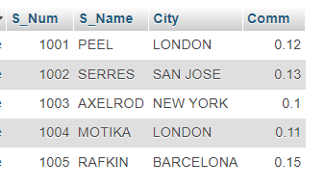

**TABLE :- CUSTOMER**

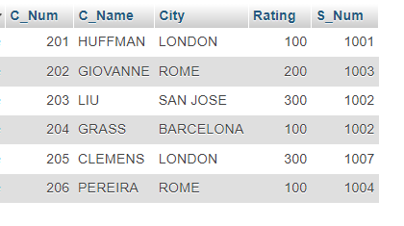

**TABLE :- ORDER**

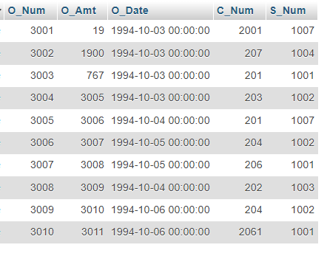

a) All orders for more than $1000.

=> [SELECT](http://localhost/phpmyadmin/url.php?url=https://dev.mysql.com/doc/refman/8.0/en/select.html) * FROM `order` WHERE O_Amt>1000;

b) Names and cities of all salespeople in London with commission above 0.10.

=>[SELECT](http://localhost/phpmyadmin/url.php?url=https://dev.mysql.com/doc/refman/8.0/en/select.html) S_Name , City FROM `sales_person` WHERE Comm > 0.10 [AND](http://localhost/phpmyadmin/url.php?url=https://dev.mysql.com/doc/refman/8.0/en/logical-operators.html%23operator_and) City ='LONDON';

c) All salespeople either in Barcelona or in London.

=>[SELECT](http://localhost/phpmyadmin/url.php?url=https://dev.mysql.com/doc/refman/8.0/en/select.html) S_Name , City FROM `sales_person` WHERE City [IN](http://localhost/phpmyadmin/url.php?url=https://dev.mysql.com/doc/refman/8.0/en/comparison-operators.html%23function_in) ('BARCELONA','LONDON');

d) All salespeople with commission between 0.10 and 0.12. (Boundary values should be excluded).

=>[SELECT](http://localhost/phpmyadmin/url.php?url=https://dev.mysql.com/doc/refman/8.0/en/select.html) S_Name , Comm FROM `sales_person` WHERE Comm > 0.10 [AND](http://localhost/phpmyadmin/url.php?url=https://dev.mysql.com/doc/refman/8.0/en/logical-operators.html%23operator_and) Comm < 0.12;

e) All customers with NULL values in city column.

=> [SELECT](http://localhost/phpmyadmin/url.php?url=https://dev.mysql.com/doc/refman/8.0/en/select.html) C_Name FROM `customer` WHERE City [IS](http://localhost/phpmyadmin/url.php?url=https://dev.mysql.com/doc/refman/8.0/en/comparison-operators.html%23operator_is) NULL;

f) All orders taken on Oct 3Rd and Oct 4th 1994.

=> [SELECT](http://localhost/phpmyadmin/url.php?url=https://dev.mysql.com/doc/refman/8.0/en/select.html) * FROM `order` WHERE O_Date [IN](http://localhost/phpmyadmin/url.php?url=https://dev.mysql.com/doc/refman/8.0/en/comparison-operators.html%23function_in) ('03-10-1994','04-10-1994');

g) All customers serviced by peel or Motika.

=> [SELECT](http://localhost/phpmyadmin/url.php?url=https://dev.mysql.com/doc/refman/8.0/en/select.html) * FROM customer WHERE S_Num = 1001 [OR](http://localhost/phpmyadmin/url.php?url=https://dev.mysql.com/doc/refman/8.0/en/logical-operators.html%23operator_or) S_Num = 1004;

h) All customers whose names begin with a letter from A to B

=>[SELECT](http://localhost/phpmyadmin/url.php?url=https://dev.mysql.com/doc/refman/8.0/en/select.html) C_Name FROM `customer` WHERE C_Name [LIKE](http://localhost/phpmyadmin/url.php?url=https://dev.mysql.com/doc/refman/8.0/en/string-comparison-functions.html%23operator_like) 'A%' [OR](http://localhost/phpmyadmin/url.php?url=https://dev.mysql.com/doc/refman/8.0/en/logical-operators.html%23operator_or) C_Name [LIKE](http://localhost/phpmyadmin/url.php?url=https://dev.mysql.com/doc/refman/8.0/en/string-comparison-functions.html%23operator_like) 'B%';

i) All customers excluding those with rating <= 100 unless they are located in Rome.

=> [SELECT](http://localhost/phpmyadmin/url.php?url=https://dev.mysql.com/doc/refman/8.0/en/select.html) C_Name FROM `customer` WHERE Rating <= 100 [OR](http://localhost/phpmyadmin/url.php?url=https://dev.mysql.com/doc/refman/8.0/en/logical-operators.html%23operator_or) City = 'ROME';

j) All orders except those with 0 or NULL value in amt field.

=> [SELECT](http://localhost/phpmyadmin/url.php?url=https://dev.mysql.com/doc/refman/8.0/en/select.html) O_Num FROM `order` WHERE O_Amt != 0 [OR](http://localhost/phpmyadmin/url.php?url=https://dev.mysql.com/doc/refman/8.0/en/logical-operators.html%23operator_or) O_Amt [IS](http://localhost/phpmyadmin/url.php?url=https://dev.mysql.com/doc/refman/8.0/en/comparison-operators.html%23operator_is) [NOT](http://localhost/phpmyadmin/url.php?url=https://dev.mysql.com/doc/refman/8.0/en/logical-operators.html%23operator_not) NULL;

k) Count the number of salespeople currently listing orders in the order table.

=> SELECT COUNT(DISTINCT S_Num) AS num_active_sales_person

FROM `order`

WHERE order_status = 'Active';